Java Final Practice - CSC205 - Victoria J. Heil

Question 1: (10 points*) Which of the following is not an operation on a stack?

**d) dequeue**

Question 2: (10 points*) A queue is a ________________ data structure.

**b) FIFO**

Question 3: (10 points* ) What is the result of evaluating the following postfix

expression: 4 8 + 2 *

**24**

Question 4:

What exception is thrown if the pop method is called on an empty stack?

**d) EmptyCollectionException**

Question 5: (10 points*) In an ideal implementations of a stack and a queue, all

operations are

**O(1)**

Question 6: (10 points*) In a array-based implementation of a queue that stores the front

of the queue at index 0 in the array, the dequeue operation is ______________.

**O(n)**

Question 7: Suppose the following sequence of elements are inserted into a

in the following order: 50, 26, 32, 18, 26, 51 of three pop operations of the stack and three dequeue operations of the queue?

Pop (Stack LIFO):

51

26

18

Dequeue (Queue FIFO):

50

26

32

Question 8: (20 Write a for a stack implemented with an array.

You may assume that the stack is referenced by an array named stack and that there is

an integer variable named that keeps track number of in the stack.

You may not assume that you have to an method (meaning that

your method should include code to expand the capacity of the array if it is full).

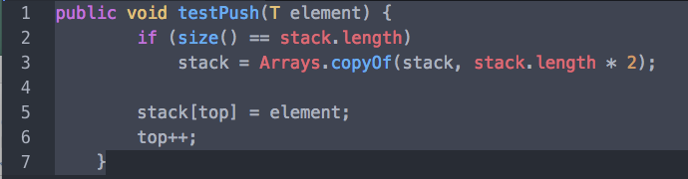

Question 9: (20 points*) Write an enqueue method for a queue implemented as a

circular array. You may assume that you have access to a method called

expandcapacity that will double the size of the array if necessary. The class has

instance variables front and rear, which represent the indexes of the front and rear of the

queue. It also has an integer variable called count that represents the number Of

elements in the queue, as well as an array of generic T types called queue that represents

the queue.

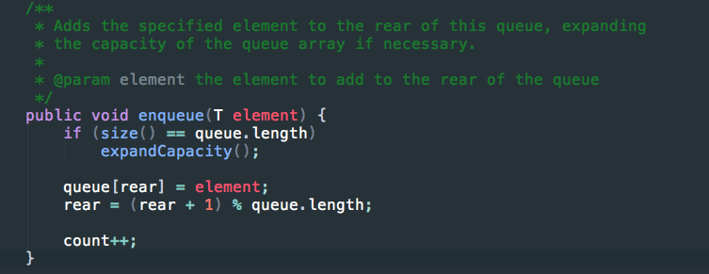

Question 10: (20 points EXTRA CREDIT*) Write an enqueue method for a queue

implemented as a linked structure. You may assume that the class has references to

objects called Front and rear, which represent the front and rear of the

queue respectively. You may also assume that the class has a variable called count,

which represents the number of in the queue.

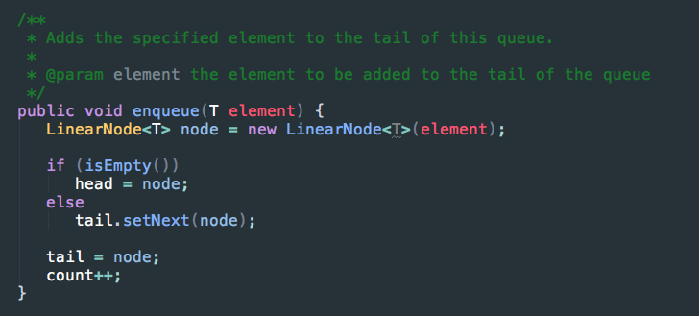

Question 11: (10 points*) ___________ recursion occurs when a method calls itself, while __________ recursion when a method calls another method that then calls the original method.

**Direct, indirect**

Question 12: (1() points*) In the Towers of Hanoi puzzle there are _____ disks of different diameters.

1. **The Towers of Hanoi puzzle can include any number of disks of different diameters.**

Question 13: (10 points*) Which of the following will result from infinite recursion in

Java?

**The program will run out of memory.**

Question 14: (10 points* ) The recursive solution of the Towers of Hanoi problem has

complexity.

**Exponential**

Question 15: (10 points*) A solution with exponential complexity is _______.

**Inefficient**

Question 16: (10 points*) Which of the following best describes a balanced tree?

**A balanced tree has all of the nodes within one level of each other.**

Question 17: (10 points*) A full binary tree of height n has ____ leaves.

**2^n**

Question 18: A balanced binary tree with m elements will have height _____

**Log2m**

Question 19: (10 points*) Which of the following traversals visits the root before

visiting the left and right subtrees?

**Preorder**

Question 20: (10 points* ) In a binary search tree, the elements in the right subtree of the

the root element root are ___the root element.

**Greater than or equal to**

